Simulations for addicts of gambling

Piet van Blokland
Department of Economics
Vrije Universiteit
Geerdinkhof 561, 1103RK Amsterdam, Netherlands
pjvanblokland@gmail.com

Gambling addiction is a serious problem in our societies. The gambling industry is a multi-billion industry with a lot of victims. Treatment for addiction has a high percentage of regression. We think that insight into the statistics involved, will help to strengthen the addicts ability to resist the temptations of gambling. Simulations are an easy way to explain variation and expectation. We describe a series of 3 lessons of 4 hours each about randomness, the gambler’s fallacy, slot machine and roulette to clarify these games in order to give better understanding. Attention is also paid to other aspects of the gambling. We tested these lessons with gamblers and gambling addicts. This approach may also be useful for public education. You can see the simulations at www.vustat.eu

Background
The percentage of persons with serious gambling problems is estimated at 1% to 5% of the Dutch adult population. It is expected to rise because of internet gambling. Especially the youth of 15 to 20 years old is an easy target for the gambling industry. The size of the gambling industry in the Netherlands measured in gross game turnover is 2.24 billion in 2014

Usually the treatment of addicts of gambling is about the craving. The probability aspects hardly get any attention. However, gamblers often have thoughts like

- The slot machine is now going to give because he has not given for a long time….
- The prize must fall now because the machine is very active now.
- If I do not take the next opportunity, then I miss the jackpot. The machine is about to give. I had two almost good.

Those thoughts drive the gambler’s emotions very strongly and are hard to resist. Kahneman (Kahnemann 2011) has made numerous observations that people are not so good in probability. It is obvious that a probability course is out of reach for this group. Simulations gives an opportunity to address these misunderstandings and help people to get stronger against the temptations of gambling.
The gambling industry itself uses the high belief in mathematics and science to promote gambling. It uses names like Fibonacci or d’Alembert for strategies with roulette, suggesting that there is scientific proof. (http://www.roulettestrategy.net/strategy/) So why not use the same strategy for better understanding? .
We can learn from the anti-tobacco movement that a good strategy is blaming the industry, providing scientific evidence and not blaming the victim. The industry has purposely caused the victim to become addicted. .

THE CLASSROOM ACTIVITIES

Activities first lesson(theme: coincidence)
There are several activities in the first lesson We will discuss two of them
Law of Small and Large numbers
It is not so easy to find clear examples of just randomness in nature. The probability of a birth of boy or girl appears to be one, which is easy to understand. In the graph below are on the x-axis the number of births in the communities in the Netherlands and on the y-axis the percentage of boys.
The graph demonstrates the law of small and large numbers. High spread for small communities and small spread for large communities.
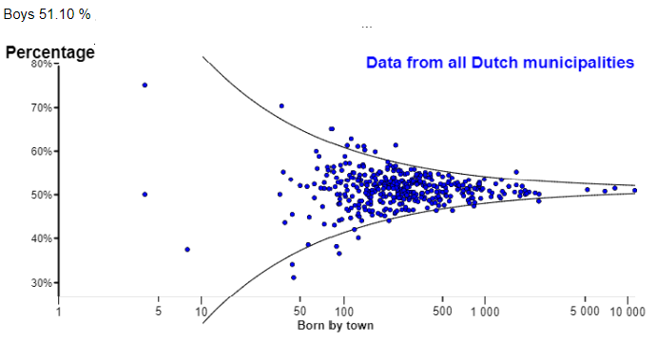
Figure 1. The percentage of boys’ births by municipality

However, if you look to the graph with on the y-axis the absolute difference between the expected number of male births and the observed number you will see a small spread for small communities and a large spread for large communities. This depends of course on the scale of the y-axis.
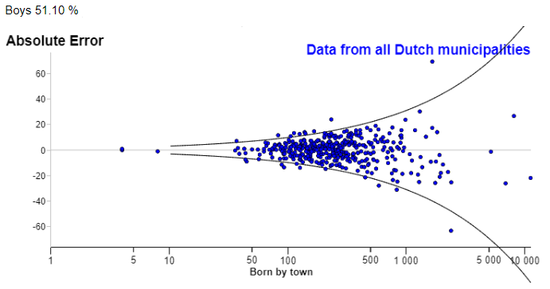
Figure 2. Absolute error of boys birth by municipality

Gambler’s Fallacy
The gambler’s fallacy is: after a sequence of ten red balls in a row the probability of another red ball gets smaller. It is not enough to tell the students that a roulette wheel has no memory. They might think: “You just told us that in the long run the percentage of red will be 50%. So, to get close to this 50% the probability of green balls must increase.” Or from another student with many years of experience of gambling: “In my life I have never seen more than 16 red balls in a row.” We discuss this issue and try to pay attention to other versions of the gamblers fallacy. The task for the students is to reformulate the sentences at the beginning. A fruit machine is a machine. Then speak to it like that.

Activities second lesson(theme: slot machine)
Slot machines are made addictive by design. (Schüll N.D.,2014). We want to demystify this machine. The first task is of course to explore the app. It sometimes takes a very long time until the observed percentage pay-out is close to the expected percentage pay-out. It may take several tens of thousands of plays before this difference is smaller than a few percent. An extra facility of this app is the calculation of cost per hour. The variation of cost per hour is large. Students can easily show that the probability of winning more than 100 dollar per hour is about 2%, while the probability of losing more than 100 dollar is about 77%. Probably they do not like this bet. Hopefully the next time they will look more at a longer time period and take a more rational approach. The profit of the bank is still there.
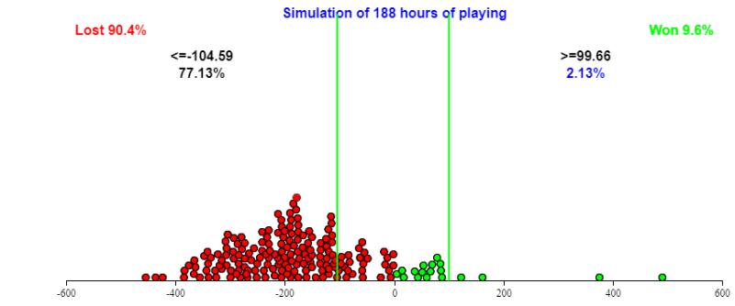
Figure 3. Profits of one hour playing the slot machine

Activities third lesson(theme: roulette)
This lesson starts by exploring the app. Ten players each with asset 300 and stake 10. A player can play the same numbers and get the same pay-off as in the official roulette. When plays start, some will win, some lose. Some get broke very soon. Some play a very long time but finally …
The next option is to play multiple times many games (for example 188 times 2500 plays) using the same strategy and look at the profits. The results of a lot of 2500 times playing can be shown in a graph. A normal roulette table plays about 250 plays a day.
You can play the doubling strategy. You start with one dollar on red. If you lose you bet 2 dollars. If you win you have won 1 dollar profit. If you lose you play again with 4 dollars et cetera.
If you simulate this then you will learn you lose 2.7% of the money you stake. Depending of your strategy the spread varies enormously.

SECONDARY SCHOOLS
We should like to put some arguments forward as to why this material is suitable for secondary school.
- A lot of the misunderstandings gamblers have, are the same as those of a lot of other people.
- Simulation is a worthwhile experience for students. A lot of classical statistics outside school is nowadays replaced by simulation methods.
- Probability theory is a hard subject for secondary school. Some experience with simulation might make things easier. It is much easier for students to explain what happens in percentage of cases.
- Some easy counting tasks, like number of possibilities in the slot machine, are valuable.
- Gambling does not have many distracting problems. It offers a clear playground, which is easy for the beginning.
- Given the size of the problem of addiction to gambling, it make sense to discuss it in school.

CONCLUSION
Based on our small experiments we can say
- Understanding of the statistics involved in gambling can make enormous progress.
- There is interest in this knowledge from people with a risky or problematic game behavior.
- Discussing this knowledge about gambling makes sense for secondary school.

REFERENCES
Kahnemann,D (2011). Thinking, Fast and Slow. Farrar, Straus and Giroux.
Schüll,N.D. (2014). Addiction by Design. Princeton University Press
Souza,M (2011). Psychology of Gambling. https://www.youtube.com/watch?v=J8PLXnqhuNc

