Teaching with VUSTAT apps.
The purpose of statistics education in founding education is to give students insight into important statistical concepts. But how do you do this? How do you make modern statistical methods and insights accessible to founding education?
We think that the 'apps' of VUSTAT can help you to achieve this aim. The VUSTAT apps are available free of charge and can be used in all common browsers on all computer platforms.
We give below further details of five of the VUSTAT apps: sampling distribution, law of large and small numbers, yes-no distribution, distributions and data analysis.

Sampling distribution
Sampling distribution is an important statistical concept. Sampling distribution can be excellently simulated with the 'Sampling distribution' app, indispensable for good understanding. This app enables you to see what you are doing, and you can follow the process well. Understanding is built up slowly, but the results can be calculated fast.
Didactical comments
I often start the app at the beginning of the lesson with standard settings at a slow pace. Then fast. Students then see the sampling distribution of the average appear. Then change the range of the sample to 100. Do one simulation and then ask the class whether the sampling distribution of the average is broader or narrower.
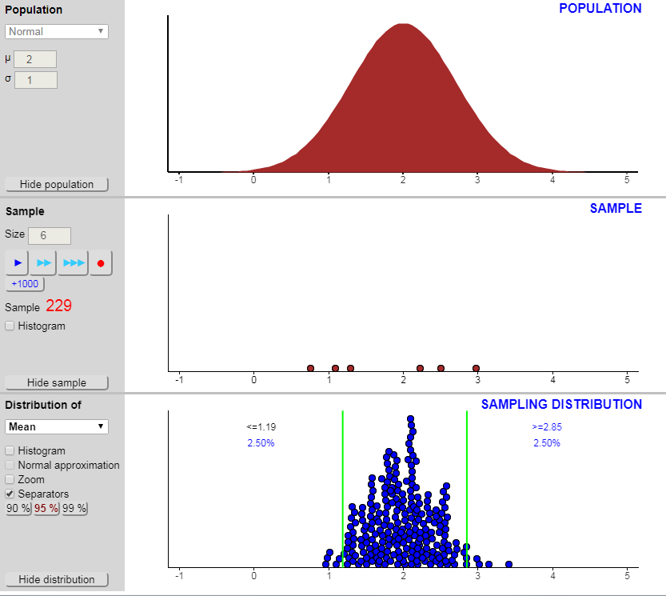
With this app you can see immediately that a sampling distribution often takes the form of a clock, with the square root law applying, even when the population distribution is far from normal. Students can check this easily with a few examples. Estimating a p value or establishing a confidence interval is very simple in this app. This is even the case in circumstances where the application of the formulae is not reliable. The app gives the student various populations from which to draw samples. The pupil can also easily construct populations him/herself, and subsequently examine these with the aid of samples.

The law of large and small numbers
It is not so easy to find clear examples of just randomness in nature. The probability of a birth of boy or girl appears to be one, which is easy to understand. In the graph below are on the x-axis the number of births in the communities in the Netherlands and on the y-axis the percentage of boys.
The graph demonstrates the law of small and large numbers. High spread for small communities and small spread for large communities.
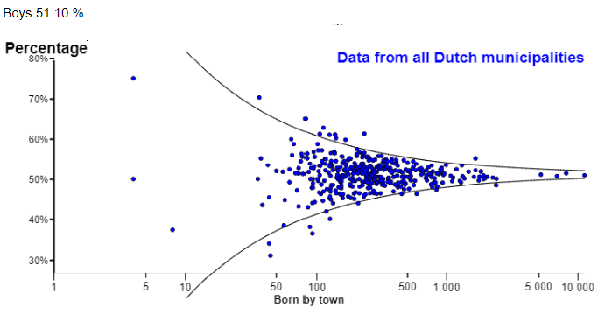
The percentage of boys’ births by municipality

However, if you look to the graph with on the y-axis the absolute difference between the expected number of male births and the observed number you will see a small spread for small communities and a large spread for large communities. This depends of course on the scale of the y-axis.
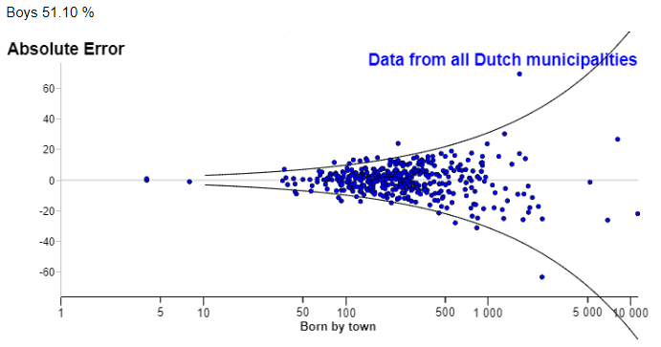
Absolute error of boys birth by municipality

Samples from yes-no population
This app, too, is a fine example of students being able to obtain insight into the relationship between sample and population. Study of sample variation with increasing and repeated samples in realistic contexts and with the aid of simulations heightens the insight into the sample concept and the relation between sample and simulation.
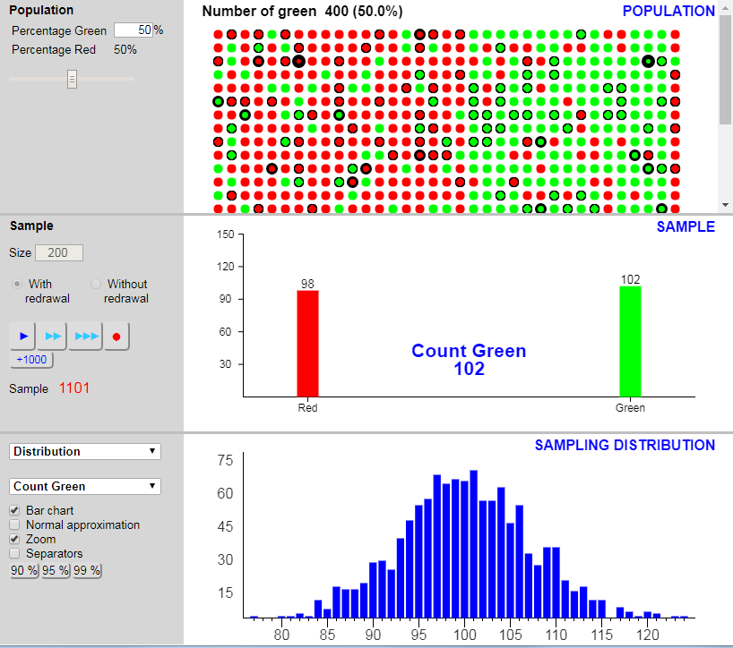
The yes-no distribution (alternative p) is eminently suitable for an easy-to-understand realistic context. The relation between the red and the green balls and the two possible results can be quickly seen.
You can take samples from this population, whether or not you put the balls back. Theoretically, in the case of the option with replacement the sampling distribution is a binomial distribution.
With the separators in the sampling distribution, you can show when a simulation has an extreme result.

Data analysis
The 'Data analysis' app provides the student with everything needed to deal with data sets, both at an elementary level and an advanced level. The app is suitable for students from 12 years old to the last two years of grammar school. The dot plot, the box plot and many other well-known diagrams can de called up in a simple way. And other items such as frequency tables, cross tables and characteristic numbers can be obtained very simply. In addition to the obvious facilities, this app also offers farther-reaching options. These include dividing into classes, grouping and comparing groups. The app also provides all manner of example data sets, such as the data set begin.json, which contains all types of variables for a finger exercise with data analysis and comparison of groups. The dataset Titanic .json gives rise to interesting questions about the relationship between sex, class, age and survival.

Distributions
With this app you can make a graph of all kinds of well-known and less-well-known probability distributions. Change the parameters and see how the graph changes. Move a boundary and see how the size of an area under the graph changes. A book of tables or a complicated procedure with a graphic calculator are no longer needed. If wished, the app can give more decimal places.
The available distributions are: Normal distribution, Binomial distribution, Hypergeometric, Poisson distribution, t distribution, χ²-distribution, F distribution, Uniform Discrete, Uniform continuous and Exponential distribution.
The presence of simple distributions such as uniform continuous opens up the possibility of discussing the idea of distributions further. A simple question what the app will show if the separators are set to 5%. might give a lot of insight.

